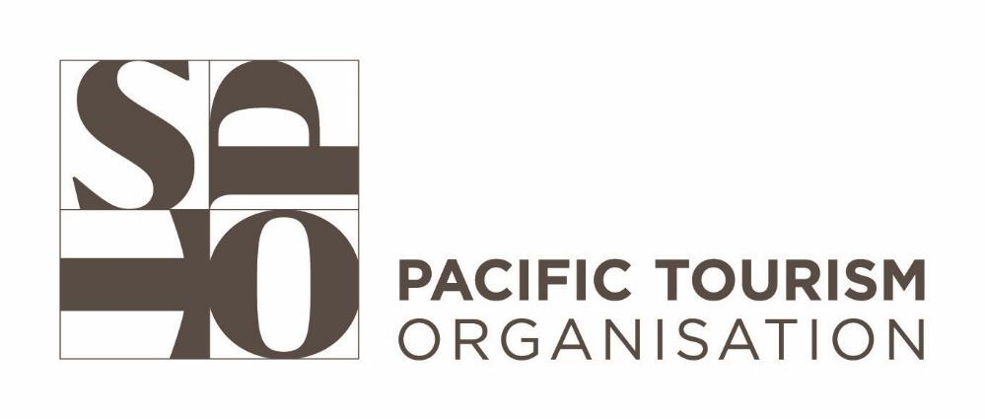

**Terms of Reference**

**Consultant: to Development of Online Learning Modules on Communications and Media in Tourism**

1. **Background:**

Following the successful completion of the New Zealand Ministry of Foreign Affairs and Trade (NZMFAT) Organizational Development and Tourism Recovery Programme (Phase 1), SPTO secured ongoing funding to implement the 4-year Pacific Digital Tourism Transformation Project (Phase 2). This phase focuses on accelerating tourism recovery in the Pacific through digital skills training and improved digital technologies and systems, with the long-term goal of creating a more resilient and sustainable tourism sector.

In light of the rapidly evolving tourism industry, where digital platforms are essential for communication, advocacy, promotion, and engagement, SPTO aims to strengthen communications capabilities for the organization and its members. To support this, comprehensive online learning modules on communications and media in tourism are required. These modules will support the implementation of SPTOs six Strategic Areas of Focus and will equip stakeholders with the tools and strategies needed to enhance communication, promote destinations, manage public relations, and utilize digital platforms to share key messages effectively.

This Terms of Reference (TOR) outlines the requirements and scope of work for a qualified consultant to develop and design the Online Learning Modules on Communications and Media in Tourism, ensuring tourism professionals can adapt to the changing digital landscape.

1. **Objectives of the consultancy:**

The main objective of this consultancy is to develop a series of online learning modules on *Communications and Media in Tourism and the implementation of SPTOs six Strategic Areas of Focus*. These modules will equip tourism professionals with the necessary skills to effectively communicate, promote, and engage with stakeholders using modern tools and techniques while emphasising the interactive nature of communication.

1. **Scope of Services**

In close collaboration with SPTO, the appointed consultant will ensure the following:

**Module Development:**

* Design and develop a comprehensive set of online learning modules for **Communications and Media in Tourism** to support the implementation of six **Strategic Focus Areas**: Responsible Destination Management, Marketing Support and Events, Research Coordination and Insights, Partnership Coordination and Support, Capacity Building and Training, and Connecting Tourism with Aviation.

**Content Creation:**

* Develop detailed content, including case studies, examples, and practical exercises, that reflect current trends and best practices in communications and media within the tourism sector.
* Ensure the content is specifically tailored to meet the unique needs of tourism professionals in the Pacific region.

**Instructional Design:**

* Utilize best practices in online learning to create engaging tutorials, incorporating multimedia elements such as videos, graphics, quizzes, and interactive assignments.
* Ensure the modules are user-friendly and accessible to individuals with varying levels of technical proficiency.

**Evaluation Framework:**

* Develop an evaluation framework, including surveys or assessments, to measure the effectiveness of the learning modules and ensure participants achieve the desired learning outcomes.
* The consultant will prepare and submit an activity work plan for approval by the project management team prior to commencement.

*\* Methodology: All of the above as well as any other requirements should be reflected in a detailed project plan and schedule. Any new technical suggestions will be welcomed and should be clearly communicated in the methodology.*

1. **Deliverables and Indicative Timelines**

*\*This may be subject to change following initial discussions with the appointed consultant*

| **SPTO Development of Online Learning Modules on Communications and Media in Tourism** | | | | |
| --- | --- | --- | --- | --- |
| **Project Milestones** | **Deliverables** | **Payment Schedule** | **Timeframe** | **Delivery Deadline** |
| Methodology | Acceptance by SPTO of the proposed methodology | 20% | Upon signing of contract November 13th - December 2 | December 2 |
| Planning and consultation process | * Submission of review and assessment of the current communications processes and SFA (across all divisions) * Provision of recommendations on addressing and synchronizing (where relevant) these communications needs, through the LMS | 20% | December 2- December 18th | December 18th |
| Drafting Process | Submission of draft layout Draft versions of all online modules, including learning objectives, content, activities, and assessments with estimated budget | 20% | January 10 –January 24 | January 24 |
| Review Period | Consultation meetings with SPTO | None | January 30th -February 11th | February 11th |
| Finalization Process | Incorporation of feedback and implementation of final changes; as per discussion and agreement with SPTO  Presentation of the Fully developed and ready-to-launch versions of the online learning modules, incorporating feedback. | 20% | February 25th | February 25th |
| **Additional On-Going Support** | | | | |
| Familiarization Process | Provide training and all necessary support to SPTO team members. | 20% | January – March | March |

1. **Project Reporting**

A first meeting will be scheduled between SPTO and the successful consultant/company to brief the firm on the background information in developing each of the requested deliverables and proposed timeline. The successful consultant/company will liaise regularly with the Regional Advocacy and Communications Officer and will report directly to the Executive & Special Projects Manager. Additional administrative and logistical support will be provided by the Executive & Special Projects Division. The consultant/company will agree on a timeframe for regular meetings for the purpose of updating SPTO on the progress of the project.

**Duration:**

* + October –March (6 months)

**Competencies and Skills Experience**

* + Instructional Design and E-Learning Development
  + Expertise in Communication Strategy Development/ Media Relations and Advocacy
  + More than 7 years of progressive work experience designing communications and media learning modules
  + Digital Content Management and CMS Expertise
  + Graphic Design and Multimedia Proficiency
  + Social Media Management
  + Crisis Communication and Management
  + Familiarity with Pacific Region Tourism Dynamics
  + Project Management
  + Strong Analytical and Problem-Solving Skills
  + Interpersonal and Stakeholder Engagement Skills
  + Portfolio of Previous Work in the development of LMS Communications and Media, blogs, videography, photography

1. **Evaluation Criteria**

Submissions will be evaluated in consideration of the following, with weighting noted in the table below:

* Bachelor's degree in Communications or Media Relations, with a background in Media Training for Tourism; Content Marketing; Digital Communications or related field will be desirable;
* More than 7 years of progressive work experience designing communications and media learning modules
* Strategizing content development and templates for the LMS
* Background in Communications and Media
* Proposed back-end support plan after the modules are developed
* Experience in developing Learning Modules
* Proposed timeline to deliver the objectives of the assignment
* The contents of the Financial Budget Proposal
* Strong understanding and broad knowledge of current photography/videography development technologies and design tools in the field and new software

Should you have any further queries regarding this consultancy post, feel free to contact [aniumataiwalu@spto.org](mailto:aniumataiwalu@spto.org)

| **Evaluation Criteria, Competency Requirements** | | **Score Weight (%)** |
| --- | --- | --- |
| **Criteria 1:** | **Qualification** | 20 |
| * Bachelor's degree in Communications or Media Relations, with a background in Media Training for Tourism; Content Marketing; Digital Communications or related field will be desirable; |
| **Criteria 2:** | **Technical experience/Criteria/Standards/Guidelines Development** | 30 |
| * More than 7 years of progressive work experience designing communications and media learning modules;   + The consultant should demonstrate a deep understanding of instructional design and the ability to develop learning modules specifically tailored to communications and media. Over 7 years of experience ensures they have the technical proficiency to create modules that effectively convey concepts, skills, and strategies to learners, particularly in the tourism sector.   + This experience should reflect an evolution in designing and updating educational materials in line with current digital trends and learner needs, ensuring that the consultant is equipped to develop relevant, engaging, and results-oriented content. |
| * Strong understanding and broad knowledge of communications strategies, media relations advocacy, and storytelling:   + The consultant should be well-versed in various communication strategies used to engage stakeholders, manage public relations, and promote destinations. This includes familiarity with both traditional and digital media, and an ability to align messages with tourism goals.   + The ideal candidate should be able to craft compelling narratives that resonate with target audiences, using storytelling techniques to promote tourism initiatives, build trust, and foster stronger connections between tourism destinations and their audiences. |
| * This experience should reflect an evolution in designing and updating educational materials in line with current digital trends and learner needs, ensuring that the consultant is equipped to develop relevant, engaging, and results-oriented content. * Understanding the latest social media trends ensures the consultant can effectively integrate social media strategies into communication plans, helping tourism stakeholders engage with wider audiences. |
| **Criteria 3** | **General Experience in Key Areas** | 30 |
| * Experience in working with government institutions, particularly National Tourism Organisations (NTOs), in developing communications strategies, communication plans, and advocacy plans in the Pacific Islands:   + The consultant should have practical experience collaborating with government bodies and NTOs to design and implement communications strategies specific to tourism promotion in the Pacific region. This includes experience tailoring strategies to the unique needs of Pacific Island destinations, considering their cultural, environmental, and economic contexts.   + Their work should demonstrate an ability to balance local and regional tourism goals, as well as the capacity to advocate for sustainable tourism practices. Experience in working with government institutions, particularly the National Tourism Organisations in developing communications strategies; communications plans, and advocacy plans in the Pacific Islands; |
| * Experience working with regional and international organizations or large-scale projects indicates that the consultant is familiar with global best practices, complex project management, and collaboration with multi-national stakeholders. This experience is beneficial for understanding diverse tourism markets and implementing communications strategies that can adapt to a range of contexts. * An understanding of international standards in tourism communication, crisis management, and advocacy is crucial to ensure that strategies align with global trends while addressing local needs. |
| * The portfolio should demonstrate the consultant’s ability to design user-friendly interfaces, produce engaging content, and successfully implement communications strategies that met their clients' goals. |
| **Criteria 4** | **Relevance of Approach/Methodology to Assignment** | 20 |
| * Provide a clear and well-thought-out Methodology for meeting the requirements of the Scope of Services and specific deliverables expected throughout the assignment. |
| * Sound and practical approach that allows for the inclusive engagement of stakeholders noting the remote delivery of outputs and diversity of issues and competing stakeholder interests |
| * Clear and realistic timeframe including confirmation of availability |
| **Total Score** | | **100** |
| **Qualification Score** | | **70** |

**Financial Proposal (30%)**

The consultant must submit a Financial Proposal based on:

* **Lump Sum Amount:** The total amount quoted shall be all-inclusive and include all costs components required to perform the deliverables identified in the TOR, including professional fees, taxes (if applicable) and any other costs to be incurred. The contract price will be a fixed output-based price regardless of any extensions. Payments will be made upon completion of the deliverables/outputs and as outlined in the Deliverables and Indicative Timeframe section above.
* The financial component of the proposal will be scored on the basis of overall costs for the delivery of the services and financial incentives and benefits provided to SPTO. The lowest financial proposal will be awarded maximum 30 points and other financial offers and incentives will be awarded points as per the formula below. The formula used for scoring points for financial values proposed will be: **Financial Proposal score = (Lowest Price / Price under consideration) x 30**
* The Financial Proposal will be considered only for bidders that passed the minimum technical score of 49 points (70%)

**Proposal Submission**

* All applications must be clearly marked with the title ***RFQ No 24/011: Consultant: to Development of Online Learning Modules on Communications and Media in Tourism*** as the subject of the email.
* All applicants to be registered on SPTO Jobslink.
* Bidders are required to fill and submit below forms:

1. **Annex II:** Please [click here](https://docs.google.com/document/d/1-UAnzRVGCVGI5pQCBbzkXp2iYMNxhKkv/edit?usp=drive_link&ouid=118409777620546307850&rtpof=true&sd=true) to view - Consultant’s Letter to SPTO Confirming Interest and Availability for the Consultancy Services
2. **Annex III:** Please [click here](https://docs.google.com/document/d/1-FZV6bYCV3w-Sk10-8ah-qzz7r_qitIz/edit?usp=drive_link&ouid=118409777620546307850&rtpof=true&sd=true) to view -Technical Proposal Submission Form
3. **Annex IV:** Please [click here](https://docs.google.com/document/d/1--cXAEvdsGNmFx73gtcwEym4utnoU0-4/edit?usp=drive_link&ouid=118409777620546307850&rtpof=true&sd=true) to view - Financial Proposal Submission Form

* Submissions are to be sent to the email address, [procurement@spto.org](mailto:procurement@spto.org) **by 18th October, 4pm (Fiji Time).**